DEFLECTION OF BEAMS
Elastic Curve: Deformed Axis of loaded beam.
Deflection (δ): Vertical Distance of a point on a loaded beam. δ = f (x)
Slope (θ): Angle made by a tangent with horizontal axis. θ = f(x)
Any Design
Strength Based Design | Stiffness Based Design
σ ≤ σ_{Allowable}  τ ≤ τ_{Allowable}  (For Safe Design) | Less Stiffness <=> More Deflection  δ ≤ δ_{Allowable}  (For Safe Design)
Standard Building Code: Permissible Deflection of beam, δ_{max} = (1/360) L_{Span}
Design any object which looks like rigid body (δ = 0).
Differential Equation of elastic Curve:
Assumptions:
- Curvature (K=1/R) is small ==> Stresses are within elastic limit
- Hook’s Law is valid.
- Material is homogenous and isotropic.
y = Deflection = δ
θ = Slope = dy / dx = y’
d²y/dx² = 1 / R = K = M / (EI) = Differential Equation of elastic curve.
EI y’’ = M
Simply Supported Beam Subjected to pure bending: y_{max} = L² / (8R) = ML² / (8EI)
Cantilever Beam Subjected to pure bending: y_{max} = L² / (2R) = ML² / (2EI)
Simply Supported Beam Subjected Temperature difference: K = 1/R = α ΔT /h
Double Integration method:
Sign Convention:
- Deflection is negative when water is falling.
- Slope is negative when water is falling.
EI y’’ = M ==> Single integration gives slope, double integration gives deflection, constants can be obtained from boundary conditions.
Notes: 1) Hinge/ roller Supports: Only restricts deflection.
2) Fixed Support: Restricts both slopes and deflections.
If Loding is discontinuous on beam, beam is divided into segments at each discontinuity and write saperate moment equation for each segment.
Disadvantage: If bending moment is not smooth function of “x”, find differential equation for each segment.
Advantage: When EI ≠ Constant, it’s very useful. And it gives full function to find θ, δ along a long.
Macaulay’s Method:
Finding Global Bending moment equation
Rules: 1) B.M Equation to be written for the last segment of the beam.
2) If load is acting only part of the section, write distance in special bracket “< x – a >”.
3) If negative term comes in special bracket, Ignore the entire term.
4) If couple is present in part of the beam, it is to be multiplied with a distance raised to power zero.
5) If distributed load is present on part of the beam, it must be extended till last segment and must be compensated by introducing equal and opposite load.
6) Quantity in the special bracket (< x – a >) integrated as whole.
Advantage: Useful for finding θ, δ at multiple location.
Moment Area Method:
Useful for finding θ, δ at specified location.
Theorem 1 (Slope): Area of curvature diagram (M/EI Diagram) between two points is equal to change in slope.
θ_{b} – θ_{a} = $\int_{a}^{b}{\frac{M}{EI}dx}$ = Area of M/EI diagram between points A&B
= (1/EI) (Area of M diagram between points A&B)
Theorem 2 (Deflection): In elastic curve AB, the vertical distance of point “B” from the tangent to the elastic curve at “A” (t_{B/A}) is equal to 1st moment of (M/EI) diagram between A & B taken moment about B.
t_{X/Y} = t_{V/T} = tangential deviation of “X” with respect to “Y”
= vertical distance form “X”
= tangent at “Y”
= area between “X” and “Y”
= moment about “X”
Formula of Area and Centroid from the Book. (Rectangle, Triangle, Parabola, 3rd degree Parabola)
Note: Draw Bending Moment by parts either from left / right.
Conjugate Beam Method (CB):
Imaginary beam with same length of real beam but the load on the C.B is “M/EI” diagram of loads on real beam.
Slope at any section of R.B. = Shear Force at that section on C.B.
Deflection any section of R.B. = Bending Moment at that section on C.B.
Real Beam | Conjugate Beam
At the End Hinge/ Roller Support | At the End Hinge/ Roller Support
At the End Fixed Support | At the End Free Support
Inertial / Internal Hinge | Intermediate Hinge
Method of Superposition:
It depends on principal of superposition.
Principal of Superposition: If the response of the structure is linear then effects of several loads acting simultaneously can be obtained by adding effects of individual loads.
Response ==> Linear Eg. Cant’s use to find strain energy
Cause ∝ Effect Eg. W (Load) ∝ δ, θ
Loading | M_{max} | θ_{max} = M_{max}L / nEI | δ_{max} = n θ_{max}L
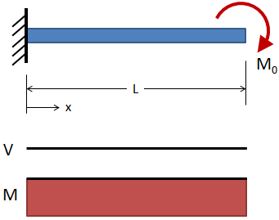 | M | Here n = 1,  ML / EI | Here n = 1/2,  ML² / 2EI
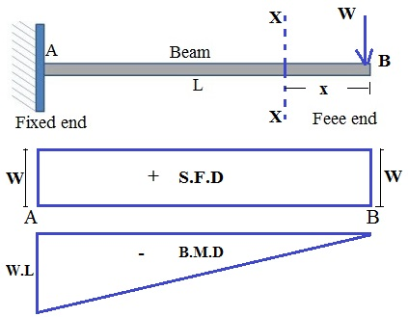 | WL | Here n = 2,  WL² / 2EI | Here n = 2/3,  WL³ / 3EI
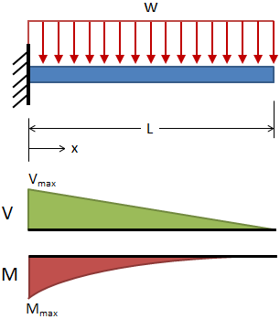 | WL² / 2 | Here n = 3,  WL³ / 6EI | Here n = 3/4,  WL⁴ / 8EI
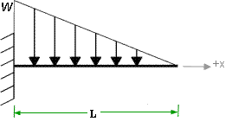 | WL² / 6 | Here n = 4,  WL³ / 24EI | Here n = 4/5,  WL⁴ / 30EI
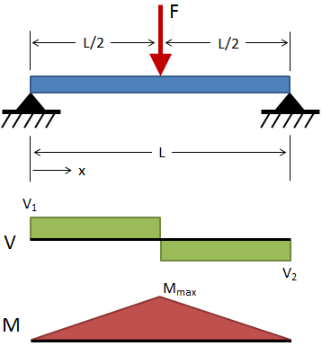 | WL / 4 | WL² / 16EI | WL³ / 48EI
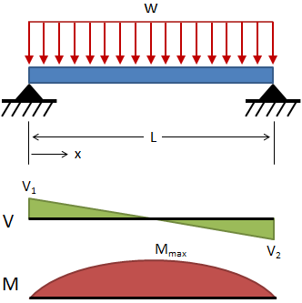 | WL² / 8 | WL³ / 24EI | 5WL⁴ / 384EI
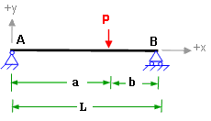 |  | Pa²b² / 3EIL
For Cantilever end: θ_{max} , δ_{max} at free end.
For Simply Supported Beam: θ_{max} at the support.
Strain Energy Method:
Castigliano’s Theorem: Used to find deflection of flames
∂U / ∂P_{i} = δ_{i} | U = $\int_{0}^{L}{\frac{M2}{2EI}dx}$
∂U / ∂M_{i} = θ_{i}

Maxwell’s Law of Reciprocal deflection:
Clerk-Maxwell's reciprocal theorem state that in a linearly elastic structure, the deflection at any point C due to a load applied at some other point D will be equal to the deflection at C when the same load is applied at D.  δ_{CD} = δ_{DC} | 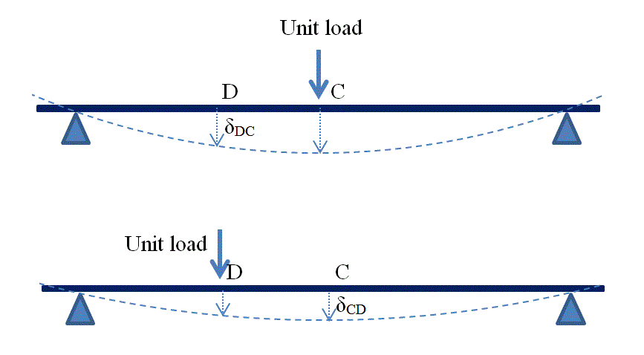

Cantilever Beams
EI = Constant | EI ≠ Constant
Method of superposition | Area Moment Method
For Frames Use Strain Energy Methods
Simply Supported Beams/ Over Hang Beams
Symmetric Loading  Area moment method | Non-Symmetric Loading
 | EI = Constant | EI ≠ Constant
 | Macaulay’s Method | Differential Equation

